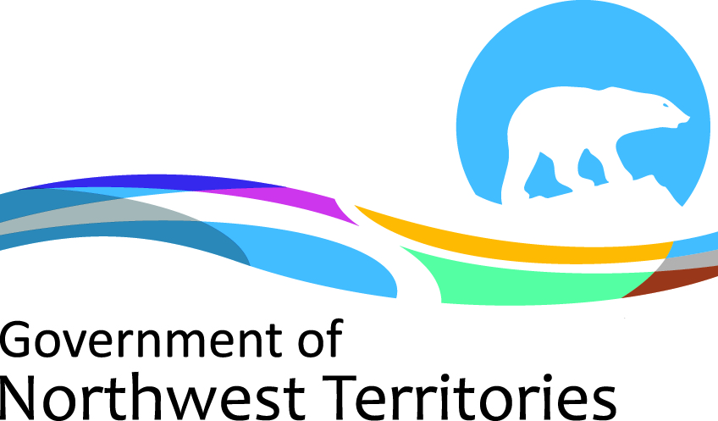

Tourism Operator Licence Fees 2019-2020

Tourism Operator Licence Descriptions | Effective April 1 2017 | Effective April 1 2018 | Effective 25 April 2019
Tourism Operators Licences - Renewals | $170 | $170 | $175
Tourism Operators Licences - New | $560 | $560 | $580
Tourism Operators Licences - Significant Amendments | $335 | $335 | $350

Please be advised that GNWT departments are taking steps to ensure that fees are adjusted regularly to keep up with inflation. Accordingly, Tourism Operator Licence (TOL) fees will increase every year on April 1 st based on the Yellowknife Consumer Price Index (CPI) of the previous calendar year.

Please note that the application fee is for processing an application and not for the licence itself. This means the fee is non-refundable, even if the application fails to receive approval.

