Summary

Climate-driven thaw of permafrost preserved
glacial landscapes, northwestern Canada

Authors:
Steven V. Kokelj¹, Trevor C. Lantz², Jon Tunnicliffe³, Rebecca Segal², and Denis Lacelle⁴
¹Northwest Territories Geological Survey, Government of Northwest Territories (GNWT),
²School of Environmental Studies, University of Victoria
³School of Environment, University of Auckland, Bag 92019, Auckland 1142, New Zealand
⁴Department of Geography, Environment and Geomatics, University of Ottawa

- Large, dynamic terrain disturbances known as retrogressive thaw slumps (Figure 1) are developing in ice-rich permafrost terrain due to the thawing of ground ice.

- A team of scientists from the NWT Geological Survey, University of Victoria, University of Auckland and University of Ottawa mapped the distribution of thaw slumps in northwestern Canada, which indicated that ground ice, tens of metres thickness underlies well over 130,000 km² of the landscape.

- Mapping across 1.27 million km² area of northwestern Canada shows that large thaw-induced slope disturbances (thaw slumps) delineate the margins of the Laurentide Ice Sheet, which covered most of Canada about 14,000 ago. Permafrost has preserved the ancient ground ice since the end of the last glaciation and now these landscapes are being dramatically altered by climate-driven permafrost thaw (Figure 2).

- Individual permafrost thaw slumps can transport hundreds of thousands of cubic metres of thawed sediment into rivers, lakes, and coastal environments changing the landscape and downstream ecosystems.

- These disturbances are transforming thousands of headwater stream catchments into major sedimentary sources. The research team found that small headwater stream catchments are disproportionally affected by the thaw slumps. This pattern of disturbance effects was unexpected because it is typically associated with processes that occur during deglaciation which occurred thousands of years ago. The research team’s data and analysessuggest that cold climate and permafrost have delayed the thawing and evolution of these ice-rich glaciated landscapes. Landscape change is now being rejuvinated by climate-driven permafrost thaw.

- The distribution of these geomorphic hotspots and the pattern of fluvial sediment mobilization signal the climate-driven renewal of deglaciation and post-glacial landscape evolution. In cold regions, permafrost has preserved relict ground-ice and vast glacial sedimentary stores in a quasi-stable state, so these landscapes retain significant potential for climate-driven transformation. This has important implications for predicting northern landscape change and the cascade of downstream impacts.

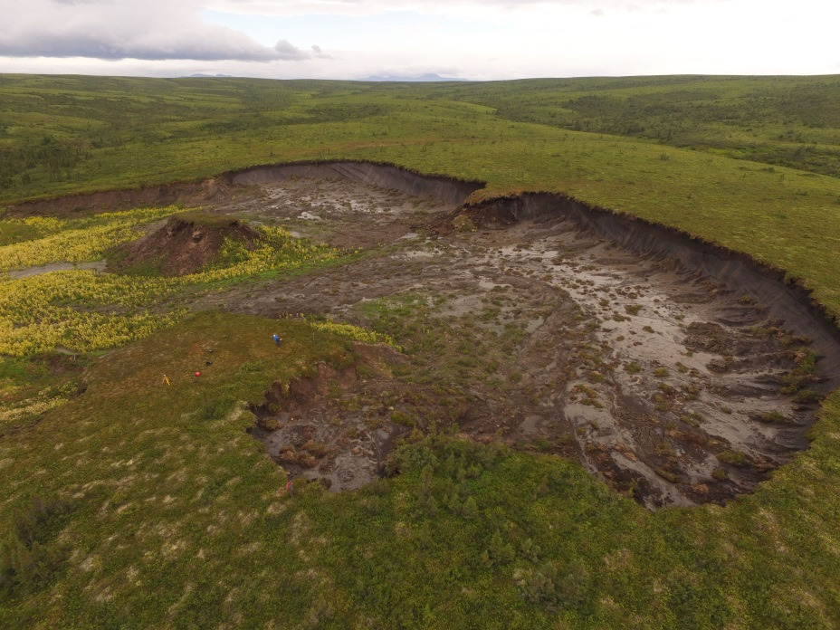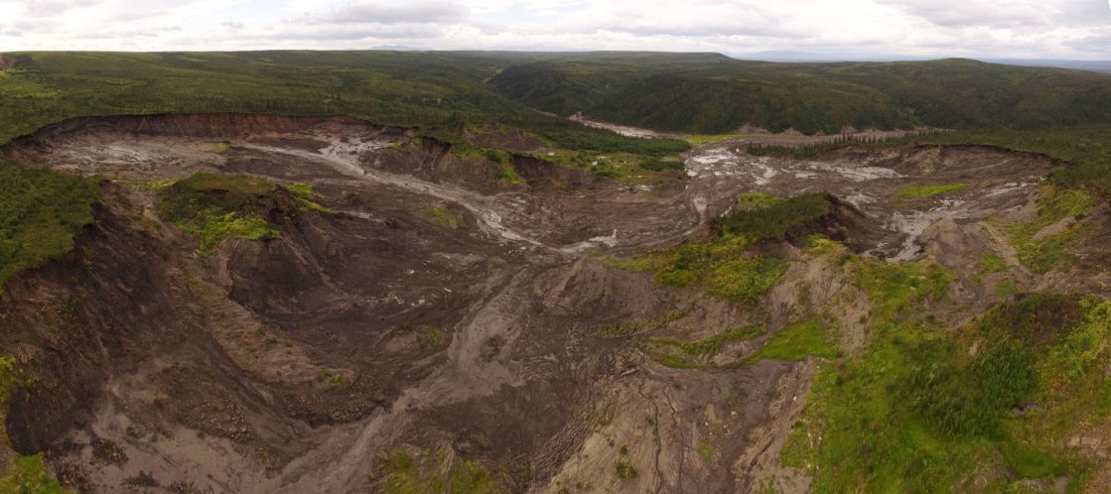
Figrue 1. Large thaw slumps on the Peel Plateau, northwestern Canada. Photographs supplied by Jurjen van der Sluijs, NWT Centre for Geomatics and Rob Fraser, Canada Centre for Remote Sensing.
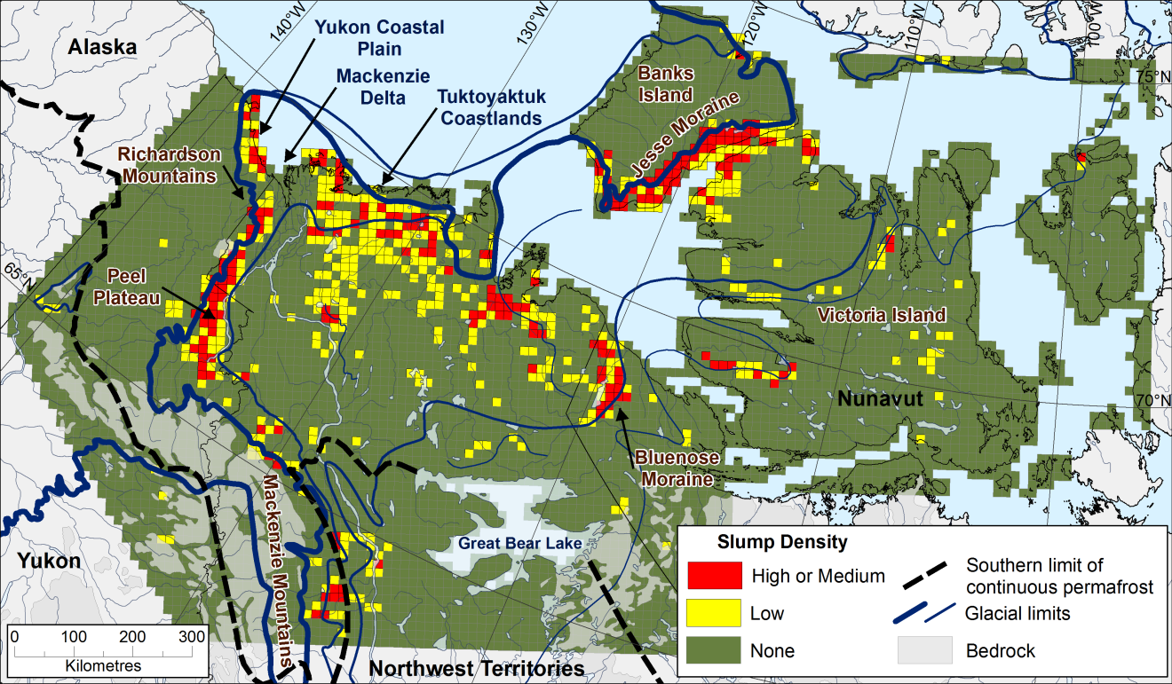
Figure 2. Thaw slump distribution and positions of the Laurentide Ice Sheet, northwestern Canada (Kokelj et al., 2017, Geol.; http://geology.gsapubs.org/content/early/2017/02/06/G38626.1.full.pdf+html).

